# Convolutional Neural Network

1. Reshape input into 28x28 matrices
2. Convert labels into One-hot vectors (e.g. 3 = [0, 0, 0, 1, 0, 0, 0, 0, 0, 0])
3. Generate new test data by scaling and rotating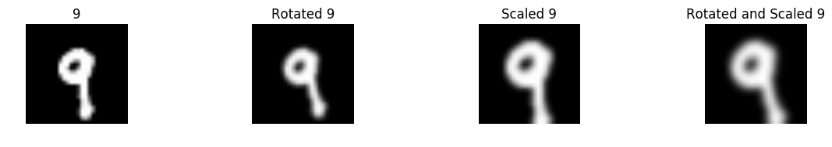
4. Train CNN in 230 epochs using all training data in each epoch

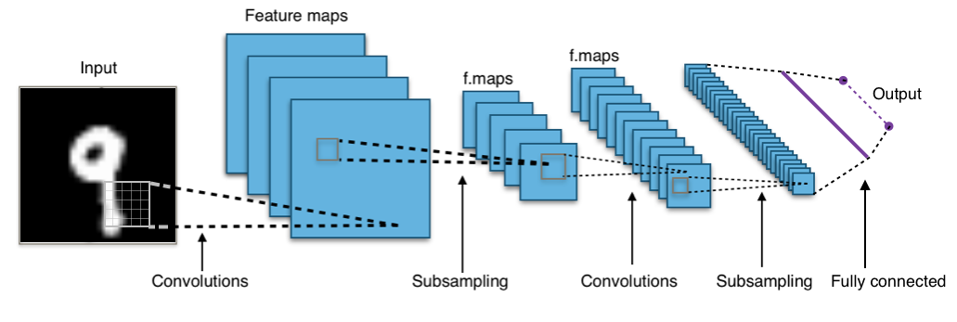

**Input:** 28x28 features

**Convolutional Layer:** 5x5 kernel, 32 features

* 32 feature maps with the shape 28x28

**1st Subsampling Layer:** 2x2 max-pooling (reduces image to 14x14)

* 32 feature maps with the shape 14x14

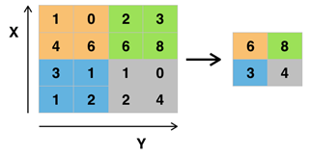

**2nd Convolutional Layer:** 5x5 kernel, 64 features

**2nd Subsampling Layer:** 2x2 max-pooling (reduces image size to 7x7)

**Fully Connected Layer:** 1024 neurons

**Output Layer:** 10 neurons (representing the one-hot vector)